AF manages family of products...Abstract Factory is factory of factory… First we need to get factory then we need to get Object........

In the below example, ShapeFactory implements getColor() which is unnecessary and ColorFactory implements getShape() which seems irrelevant.

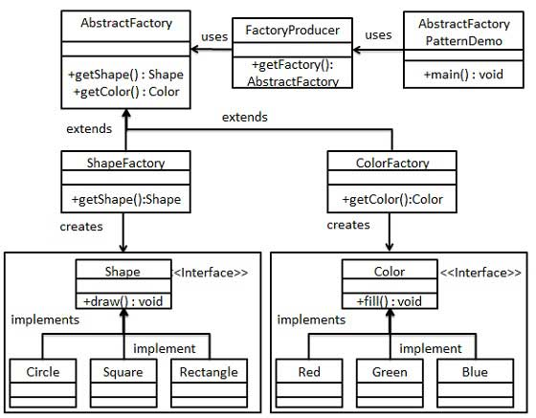

//get shape factory
AbstractFactory shapeFactory = FactoryProducer.getFactory("SHAPE");
Shape shape1 = shapeFactory.getShape("CIRCLE");

//call draw method of Shape Circle
shape1.draw();

//get color factory
AbstractFactory colorFactory = FactoryProducer.getFactory("COLOR");
Color color1 = colorFactory.getColor("RED");

//call fill method of Red
color1.fill();

